**TOUCH SENSOR(ttp223)**

**ABOUT SENSOR:**

It is basically a capacitive touch sensor. It is an electronic sensor used in detecting a physical touch. It is also known as tactile sensors. It’s a small, simple, low-cost sensor made to replace old mechanical switches we seen in the past.

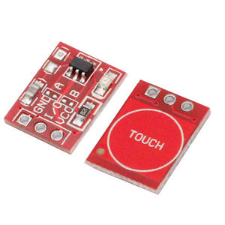

**WORKING:**

-The user applies touch on the glass panel which is capacitive.

-The printed circuit panel around the outer viewing area of the glass panel creates an electrical charge across the surface which leads to loss of charge.

-It results in a decrease in capacitance and allows the system to determine the touchpoint.

-It gives high signal in output if somebody touches the touchpad.

**INTERFACING OF THE SENSOR WITH ARDUINO UNO**

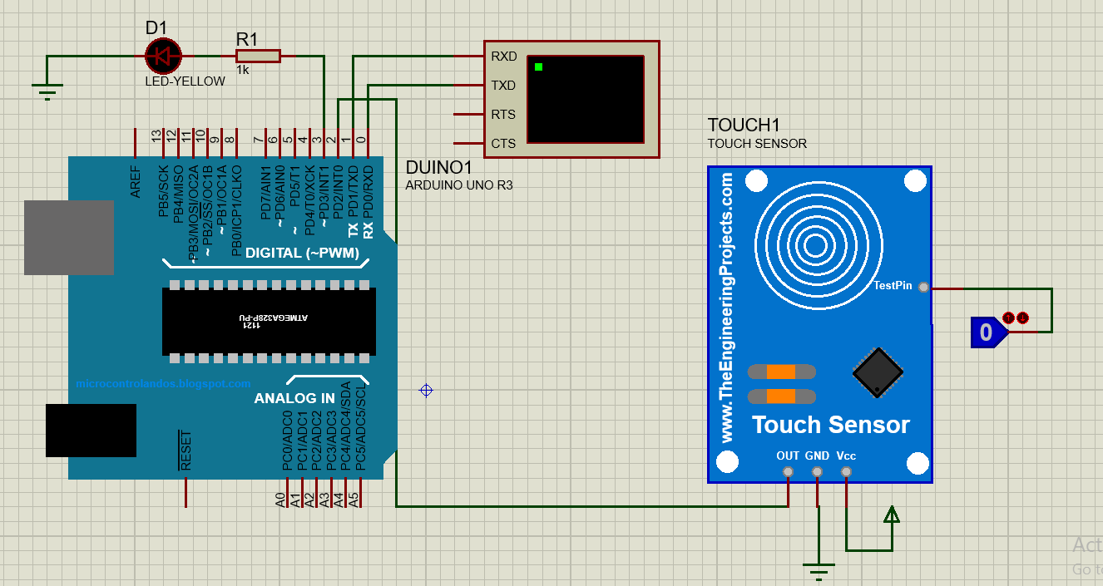

**PINOUTS:**

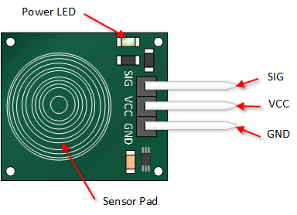

|  |  |  |
| --- | --- | --- |
| **PIN NUMBER** | **PIN NAME** | **PIN DESCRIPTION** |
| 1 | Out | The output of the digital signal(1/0) is taken from this pin. |
| 2 | Gnd | This pin is connected to the ground. |
| 3 | Vcc | The supply voltage of 5v is given to power the sensor from the Arduino. |

**APPLICATIONS:**

* Portable devices such as smartphones and tablets (iPhones, iPad, etc.)
* Home applications such as touch lamps.
* Auto motives.
* Industrial purposes.
* Can be used for touch based tap.

**CODE:**

void setup() {

// put your setup code here, to run once:

pinMode(2,INPUT);

Serial.begin(9600);

pinMode(3,OUTPUT);

}

void loop() {

// put your main code here, to run repeatedly:

int s=0;

s=digitalRead(2);

if(s!=0){

digitalWrite(3,HIGH);

Serial.println(s);

delay(1000);

}

}